Ideation Phase

Define the Problem Statements

Date | 19 February 2026
Team ID | LTVIP2026TMIDS89796
Project Name | Heritage Treasures: An In-Depth Analysis of UNESCO World Heritage Sites in Tableau
Maximum Marks | 2 Marks

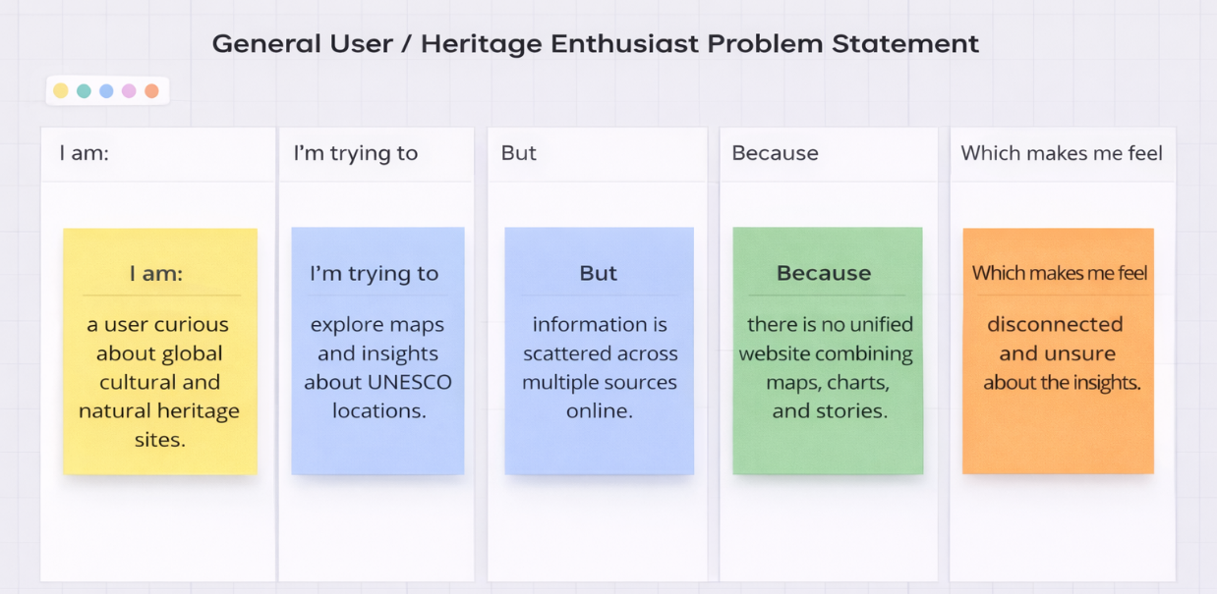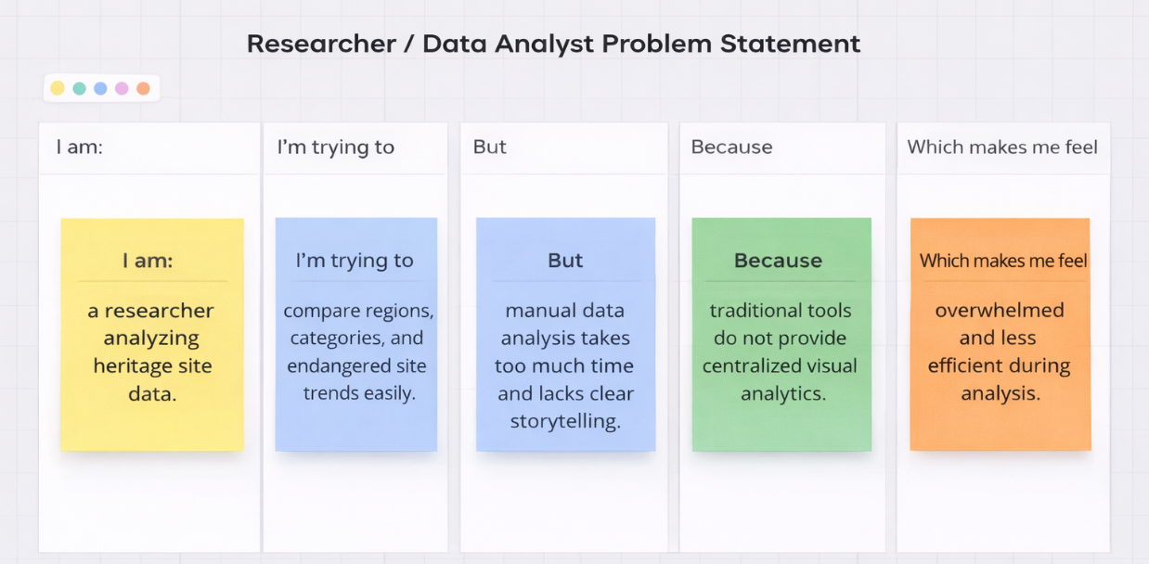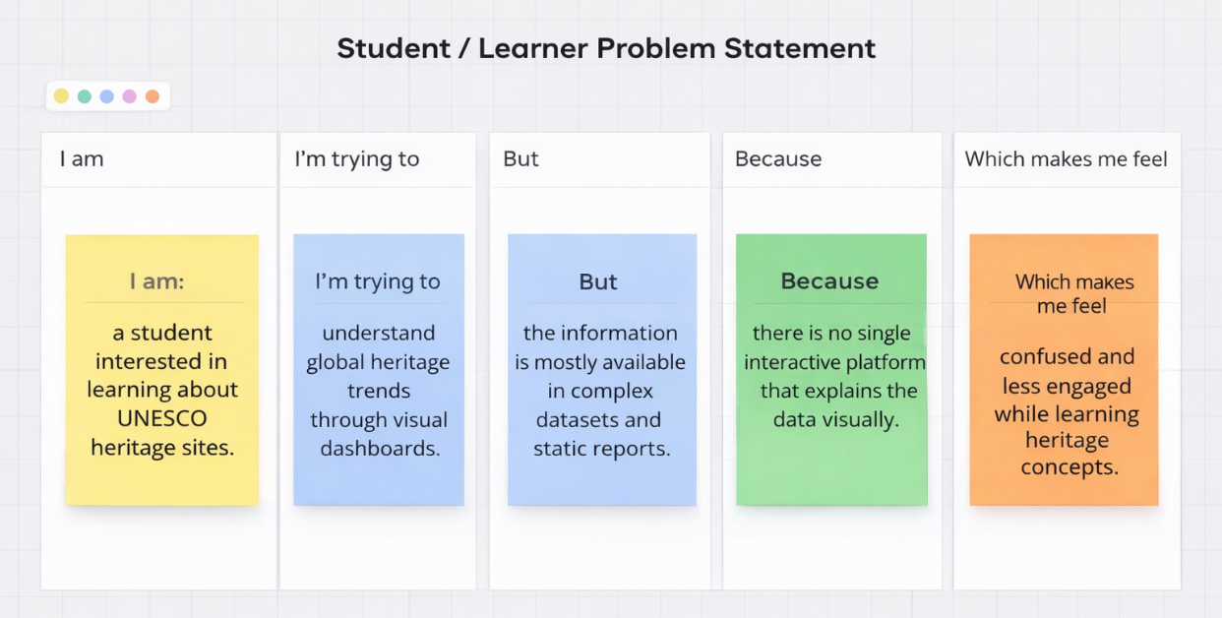

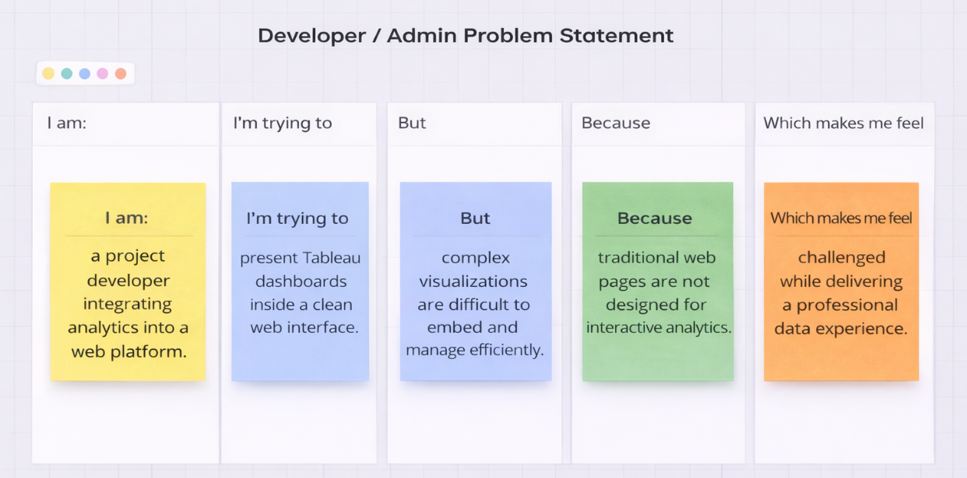

Problem Statement (PS) | I am | I’m trying to | But | Because | Which makes me feel
PS-1 | A student or researcher interested in heritage data | Explore UNESCO heritage site trends and regional distribution | The data is available only in complex tables and reports | There is no simple interactive visualization platform | Confused and unable to understand insights easily
PS-2 | A data analyst working with heritage datasets | Analyze categories such as cultural, natural, and mixed sites | Manual analysis takes more time and effort | Lack of centralized dashboards with visual storytelling | Overwhelmed and less productive
PS-3 | A project developer creating analytics dashboards | Integrate visualizations into a web application | Traditional web pages cannot present complex analytics clearly | Limited integration between data visualization and web systems | Challenged while presenting data professionally
PS-4 | A general user exploring global heritage information | Learn about endangered sites and historical trends | Information is scattered across multiple sources | There is no single interactive platform combining maps and analytics | Disconnected and less engaged with the data

Reference: https://miro.com/templates/customer-problem-statement/

